Geometry and Measurement Pre-Test

Name - _______________________ Date - ___________

1. Choose all of the following terms which describe the given shape.

* Rectangle
* Quadrilateral
* Kite
* Rhombus
* Square
* Polygon

|  |
| --- |
| 8 ounces = 1 cup |
| 2 cups = 1 pint |
| 2 pint = 1 quart |
| 4 quarts = 1 gallon |

1. Use the chart to answer the following question.

How many cups in 23 gallons?

1. 368
2. 184
3. 46
4. 92
5. Find the volume of the following figures.



Answer - ________________ units

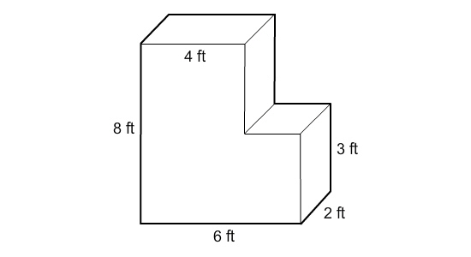

Answer - ____________________

1. **Plot** and **label** the following points on the given coordinate grid.

Point T – (9,2)

Point W – (5,4)

Point X – (2,9)

Point Y – (4,5)

Point Z – (0,7)

