Volume Post-Test
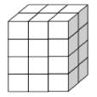
Name - __________________________ Date- ______________
- Find the volume

__________ Cubic units

- Find the volume (please label your answer correctly)

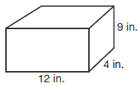

Answer _______________

- What is the volume of a regular rectangular prism with the following measurements? (please label your answer correctly)
L = 14 centimeters
H = 8 centimeters
W = 5 centimeters

Answer _____________________
- What is the volume of the following irregular rectangular prism? Please label your answer correctly.
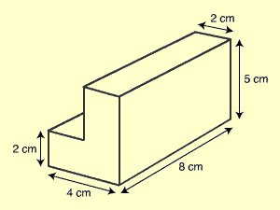 Answer ________________________
How did you solve the problem above? Explain your thinking using high level vocabulary.
________________________________________________________________________________________________________________________________________________________________________________________________________________________________________________________________________________________________________________________________________________________________________________________________________________________________________________________________________________________________
- There are a bunch of boxes in Mr. Folau’s garage. He wants to put them all together in one larger box. Each of the small boxes measures 2 in. by 3 in. by 3 in. The large box is 14 in. by 12 in. by 14 in. How many of the smaller boxes will fit inside the larger box?

Answer ____________________

